Day Trip to Debre Libanos Monastery and Blue Nile Gorge

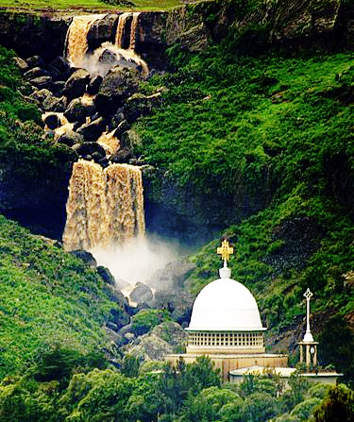
Duration - Full day Tour
Mode of transportation: - Car
Meet your guide from your hotel or at the airport and drive to Debre Libanos monastery.
Debre Libanos Monastery to learn about Ethiopia's Orthodox Christian history. Current buildings include the church over Tekle Haymanot's tomb, an older Church of the Cross and five religious schools. A nearby cave contains a spring where the water is considered holy and is the object of pilgrimages. About 105km from Addis Ababa, Debre Libanos is one of the best trips to make from the Ethiopian capital. The monastery and church northwest of the city have played an important role in Ethiopian Orthodox Christian religious history. Next, a short walk will lead you to the often-called Portuguese Bridge, which was built around the turn of the 16th century. The bridge spans the small Gur River which, just a few meters farther, pours into a 600m (1968ft) high waterfall down into the canyon. and you have a chance to see one of the endemic baboon Gelada baboon which is well known by the red color on their chest. Take a break for lunch at a restaurant Ethio German Hotel. then you will drive back to Addis Ababa.

